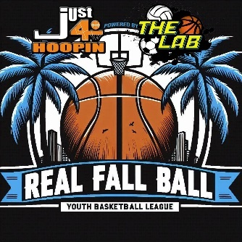

REAL FALL BALL LEAGUE
October 5 – November 23, 2024
(Medical Release Form)

I _______________________ the Head coach of ______________________________________
In accordance with The LAB / Just4hoopin, I give my consent for the boys / girls listed on my official roster to participate in 2024 Real Fall Ball League – October 5 thru November 23, 2024, at The LAB / AZ Compass / LFPA / Sequoia Charter School. I also consent to all the gym locations securing medical attention/transportation deemed necessary in an emergency. I will not hold The LAB / Just4hoopin responsible for injury or liability and will secure adequate insurance for my team. The LAB nor Just4hoopin will NOT be responsible for medical costs. I recognize there are risks associated with strenuous physical exertion when engaging in basketball activities. I certify to the best of my knowledge that each and every member of my team is physically capable to participate in the demanding activities. I, the undersigned, have read this release and understand all its terms.

Head Coaches signature _____________________________________ Date ______________

