Alabama Hustlers
Magic City Rumble
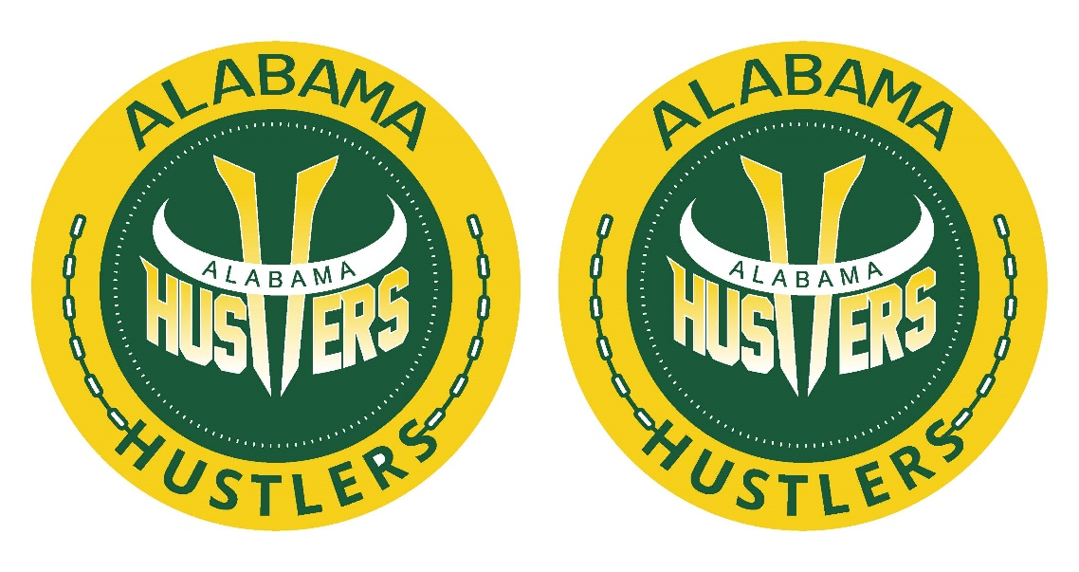

Friday Admission
Adults $10
Child $10

