ADMISSIONS

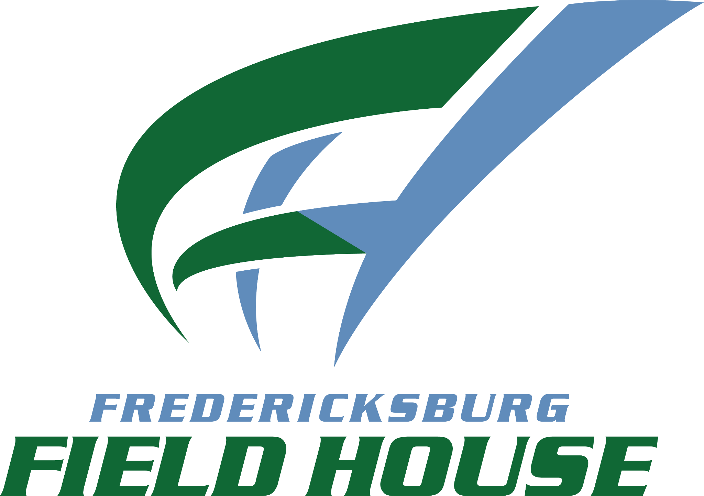

2 - DAY PASS

ADULT - $20 (AGES 16+)

YOUTH - $15 (AGES 5 - 15)

*CHILDREN 4 AND UNDER = FREE*

CASH ONLY

