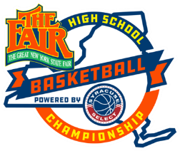

New York State Fair High School Boys Basketball Championship Rules
• Two 20 Minute Running Clock Halves. Time will stop in the last minute of the 1st half. ELAM ending for the second half
• Each team will be granted 3 Timeouts per game.
• A 29.5 size ball will be used for all divisions except 10u. 10u will use a 28.5 size game ball.
•Bonus: 1-1 will be on the 7th team foul of each half and 2 shots on the team’s 10th
foul of each half PRIOR to ELAM ending. During the ELAM ending any common foul the other team will get one free throw and retain possession of the “BALL”.
•Each Player will be disqualified on their 6" personal foul.
• All technical fouls will be 2 points and the ball. NO SHOTS WILL BE TAKEN. Ball will be placed back into play at the point of interruption.
New York State Fair Basketball Tournament Personal can at any time reserve the right to remove any Coach, Player and or fan from the New York State Fair Basketball Tournament for any behavior we deem unsafe and/or unsportsmanlike.
Derogatory name directed at any other player will not be tolerated. A technical
will issued without warning.
•The Championship game is a single elimination game. If the team from the losing side of the brackets wins the championship game will not be played again.
2025 Elam Ending Rules
• Any stoppage (i.e substitution, foul call or timeout called) Under four Minutes remaining in the game, the gameclock is turned off.
• Five points is added to the leading team's score to create the target score. For example, if the score is 70-64 when the game clock is shut off, the target score will be 75. The first team to the target score wins the game.
• If a team is up by 20 points or more at the first dead ball under 4 minutes there will not be an ELAM ending• The 10u division will not have ELAM endings. Just two 20 minute halves.

