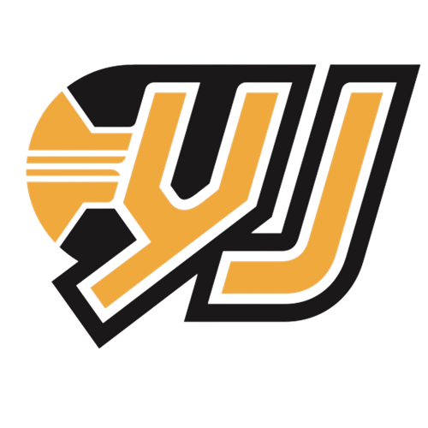
Yellow Jackets Fall Ball Classic Rules (HS TEAMS ONLY)
- There will be a minimum of two minutes warm-up between games.

- Teams will be subject to forfeit 5 minutes after scheduled start time.

- The first team listed or the TOP team listed on the bracket will be the home team.

- Home team will be responsible for game ball.

- Games will consist of two 18 minute halves with a running clock. Halftime will be 1 minute. No shot clock

- The clock will stop in the last 2 minutes of the second half if the game is within 10 points for the remainder of the game.

- The final 2 minutes of regulation and all overtime periods will be officiated with standard NFHS rules (no shot clock). All free throws during this time will be shot during double bonus, shooting fouls and technical fouls.

- All overtime periods will be sudden death. The first team to score any points will win the game!

- Players will foul out on their 6th foul

- With the exception of the last 2 minutes of the 2nd half, all shooting fouls will receive 1 free throw for a total of 2 points (receive 1 free throw for a total of 3 points on a 3pt shot attempt).

- If the player is fouled in the act of shooting and the basket goes in, the team will receive 3 points (4 points on the 3pt shot attempt)

- BONUS – Teams will enter the bonus on their opponents 7th team foul. Player fouled will shoot 1 free throw plus the bonus.

- In the event of a technical for unsportsmanlike behavior, the team will be awarded two points and will get the ball out of bounds. (Exception: technical foul that is not due to unsportsmanlike conduct or behavior)

- Any player receiving a second technical foul due to poor sportsmanship or behavior will be disqualified from the current game.

- Timeouts: 3 per game with no carryover to OT
  - All timeouts will be 1 minute

- Admission each day:
  - 18 and Older: $15.00
  - 6 – 17 Years: $10.00
  - Kids 5 and under: Free

